ON-LINE APPLICATION Guidance
(以“MSc Money, Banking and Finance”为例)
Step 1: 登陆http://www.birmingham.ac.uk/students/courses/index.aspx，并选择你要读的专业，例如MSc Money, Banking and Finance (Taught)

Step 2: 点击进入，页面右下角出现如下图示，点击进入申请界面。
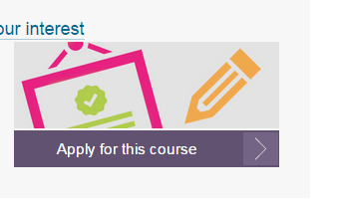

Step 3: 选择MSc (Taught):Money, Banking and Finance (FT)选项，点击apply now; (如下图)
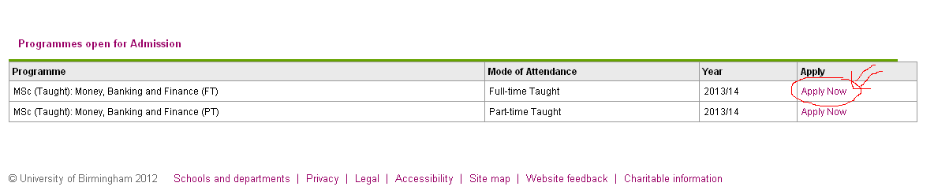
Step 4: 点击‘New User’进行注册;
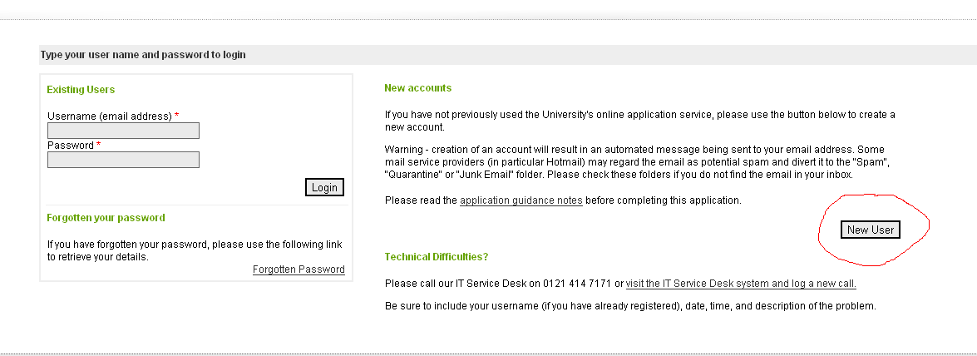
Step 5: 本项目学生须使用报名时提供的邮箱进行注册；
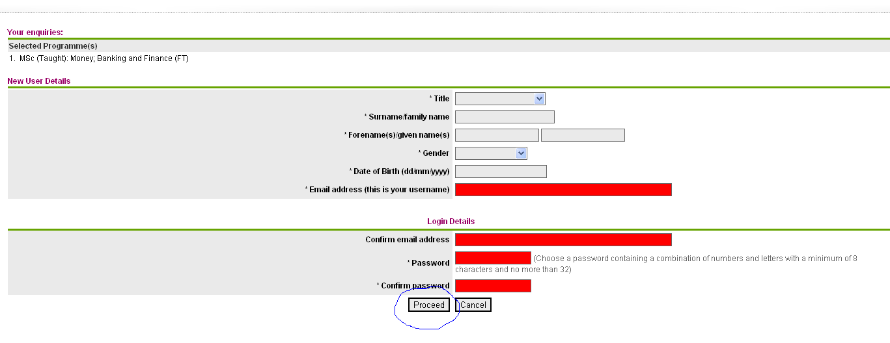
Step 6: 按照操作进行注册，并点击开始进入填写网申申请表。
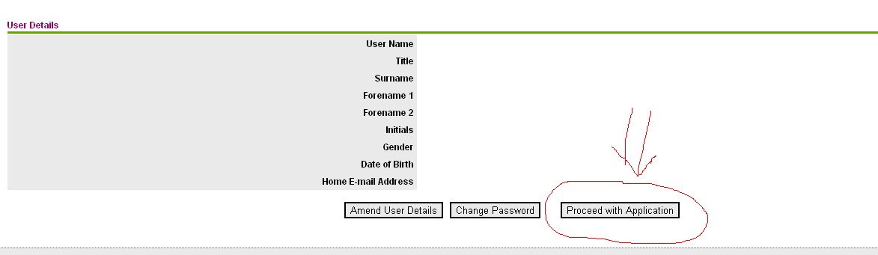
注意：填写”Agent/Partner Institution”部分有两个问题 (under the “Contact Details” section) :
- Are you applying via a University of Birmingham overseas representative or partner institution – 选择 “yes”
- Please select your University Overseas Representative or partner institution from the list – 滚动到下拉菜单底部选择“南开大学”

